Team Evaluation

1. Brendan Rizzo
   1. Worked with me, Eden Seo, to solve problem 2 part a and b, which is exercise 3.3
2. Richard Huang
   1. Solved problem 1 part a by himself and explained to us how he got the answer.
3. Jiashang Cao
   1. Solved problem 1 part b
4. **Eden Seo**
   1. Worked with Brendan to solve problem 2 part a and b, and solved part c and d by myself.
   2. 1. 1. 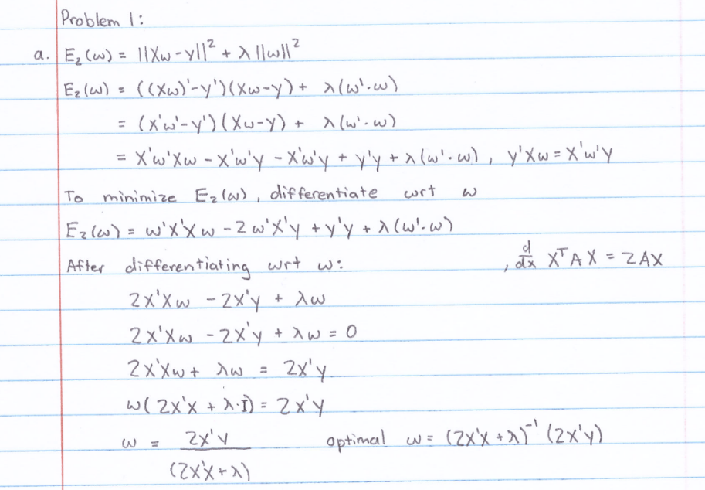 (hand-written work is much easier to see, so here it is.)
$From 1a, we got optimal$ $w={\left(2X^{T}X+λ\right)}^{-1}\left(2X^{T}Y\right).$ $$In this case, the solution holds only when 2X^{T}X+λ is \\ non singular, and since λ>0 and it is an user specific parameter, \\ the new objective function overcomed the singularity problem \\ of X^{T}X using the parameter λ.$$

5. Exercise 3.3 in LFD
   1. Show that H is symmetric.
 $H^{T}={\left(X{\left(X^{T}X\right)}^{-1}X^{T}\right)}^{T}=\left(X^{T}{\left(X^{T}X\right)}^{-T}X\right)=\left(X^{T}{\left(XX^{T}\right)}^{-1}X\right)=since X^{T}X is invertible, H^{T}=\left(X{\left(X^{T}X\right)}^{-1}X^{T}\right)=H$

  2. Show that $H^{K}=H for any positive integer K.$
 $H^{K}={\left(X{\left(X^{T}X\right)}^{-1}X^{T}\right)}^{K}=\frac{XX^{T}}{X^{T}X}*\frac{XX^{T}}{X^{T}X}*…\frac{XX^{T}}{X^{T}X} \left(for K amount of time\right)$

 $since X^{T}X is invertible,\frac{XX^{T}}{X^{T}X} is equal to\frac{X^{T}X}{X^{T}X} which is equal to 1.$

 $So no matter how many time H is multiplied by itself, it will still be the same.$

$If K=2$

$\left(X{\left(X^{T}X\right)}^{-1}X^{T}\right)*\left(X{\left(X^{T}X\right)}^{-1}X^{T}\right)= X{\left(X^{T}X\right)}^{-1}\left(X^{T}X\right){\left(X^{T}X\right)}^{-1}X^{T}=X{\left(X^{T}X\right)}^{-1}X^{T}$

3. Show that $Show that {\left(I-H\right)}^{K}=I-H for any positive integer K.$
 $if K=2$

 ${\left(I-H\right)}^{2}=\left(I-H\right)\left(I-H\right)=II-IH-HI+H^{2}=I-2H+H^{2}, and since H^{2}==H, I-2H+H=I-H$

 $Since I^{k}, where K is a positive integer, is equal to I and H^{K} is always equal to H,$

$it would always become I-H$

4. Show that trace(H) = d + 1

$Lets say that A=X{\left(X^{T}X\right)}^{-1} and B=X^{T}$

$trace\left(AB\right)=trace\left(BA\right)=>trace\left(X{\left(X^{T}X\right)}^{-1}X^{T}\right)=trace\left(X{X^{T}\left(X^{T}X\right)}^{-1}\right) which is equal to trace\left(I_{\left(d+1\right)*\left(d+1\right)}\right)=d+1$

$So trace\left(H\right)=d+1$